**Byte Stream**

**Input Stream:**

Source -> inputStream

Java input stream hierarchy

Eg:

FileInputStream:

File(Source) -> inputStream

**Input Stream:**

outputStream -> destination

Java output stream hierarchy

Eg:

FileOutputStream:

outputStream -> File(Destination)

**Character Stream**

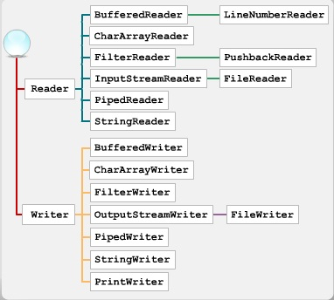

**Reader:**

Source -> Reader

Eg:

(1)

FileReader is a reader

File(Source) -> Reader (Character stream)

(2)

InputStreamReader is a reader

InputStream(source) -> Reader(character stream)

**Writer:**

Writer -> Destination

Eg:

(1)

FileWriter is a writer

Writer (Character Stream) -> File (Destination)

(2)

OutputStreamWriter is a writer

Writer(Character Stream) -> OutputStream (destination, byteStream)